**Project Initialization and Planning Phase**

| Date | 1 March 2024 |
| --- | --- |
| Team ID | 740009 |
| Project Name | Student Adaptability Level of Online Education |
| Maximum Marks | 3 Marks |

**Define Problem Statements (Student Adaptability to Online Education):**

Create a problem statement to understand the students' perspectives on adapting to online education. This template helps focus on what matters to create experiences that students will find effective and engaging. A well-articulated student problem statement allows you and your team to find the ideal solution for their challenges. Throughout the process, you will also be able to empathize with the students, helping you better understand how they perceive online education

|  |  |  |  |
| --- | --- | --- | --- |
| |  |  | | --- | --- | |  |  |   I am | Describe the student and their attributes here |
| I ‘m trying to | List the thing they are trying to achieve here |
| But | Describe the problems or barriers that get in the way here |
| Because | Describe the reason the problems or barriers exist |
| Which makes me feel | Describe the emotions that result from experiencing the problems or barriers |

Reference: <https://miro.com/templates/student-problem-statement/>

**Example:**

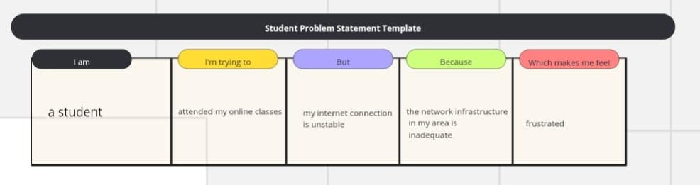

| **Problem**  **Statement (PS)** | **I am**  **(Student)** | **I’m trying to** | **But** | **Because** | **Which makes me feel** |
| --- | --- | --- | --- | --- | --- |
| PS-1 | A High school student with limited access to technology. | Participate actively in my online classes. | I often face technical difficulties and lack of reliable internet | My home environment does not provide the necessary resources | Frustrated and anxious about my academic performance. |
| PS-2 | A university student living in a remote area. | Submit my assignments on time. | I struggle with slow internet connectivity and power outages. | The infrastructure in my area is underdeveloped. | Stressed and concerned about falling behind in my coursework. |